Housing Price Prediction – Data Analytics Report

1. Objective
The objective of this analysis is to explore the Housing Prices dataset, identify key factors affecting house prices, and build regression models to predict prices accurately.

2. Data Overview
- Total samples: 545
- Features: 13
- Target variable: price
The dataset includes structural attributes (area, bedrooms, bathrooms) and amenities (air conditioning, parking, etc.).

3. Methodology

Data Preprocessing
Categorical variables were converted into numerical values for modeling.

Model Training
Multiple regression models were implemented:
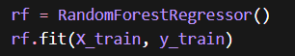

Evaluation Metrics
Models were evaluated using:
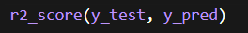
• R² Score → Model accuracy
• RMSE → Prediction error

4. Exploratory Data Analysis

Correlation Heatmap
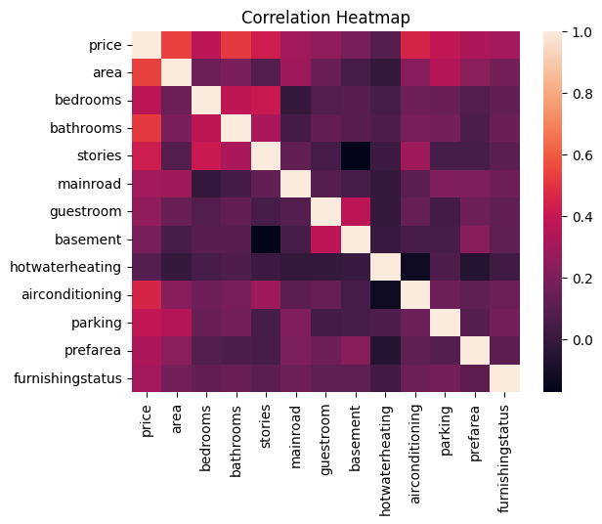
Insight: Area, bathrooms, and air conditioning strongly influence price.

Area vs Price (Trend Line)
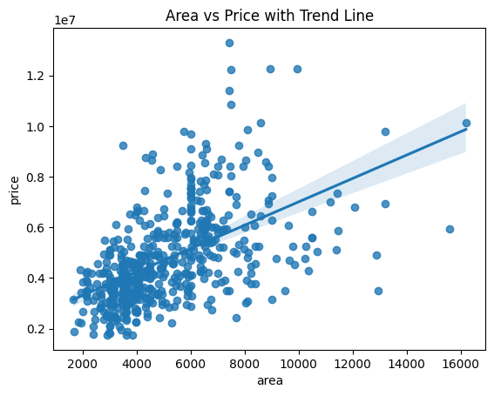
Insight: Larger houses generally have higher prices.

Bedrooms vs Price
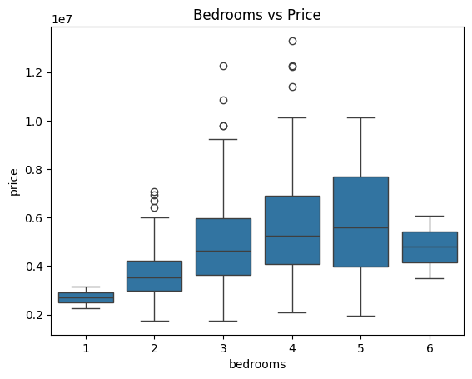
Insight: More bedrooms increase price, but not strictly linear.

5. Model Performance
Model | R² Score | RMSE
Linear Regression | 0.649 | 1.33M
Decision Tree | 0.444 | 1.67M
Random Forest | 0.613 | 1.39M
Gradient Boosting | 0.665 | 1.30M
Best Model: Gradient Boosting

6. Model Evaluation

Actual vs Predicted Plot
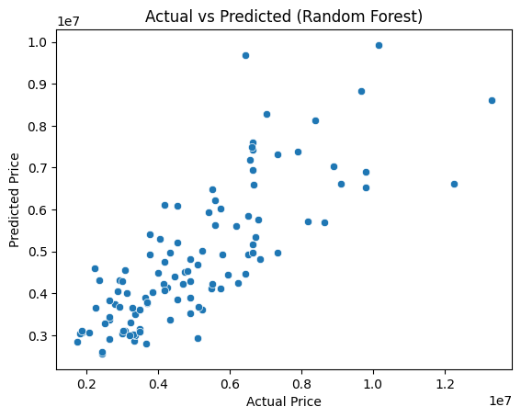
Insight: Predictions align well with actual values.

Feature Importance (Random Forest)
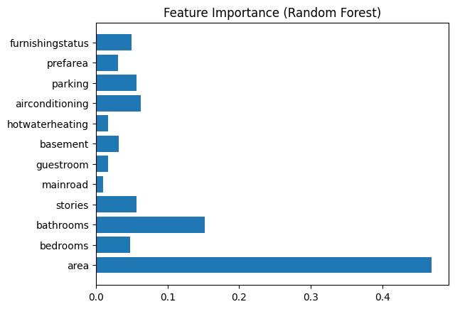
Top Features:
- Area
- Bathrooms
- Stories
- Air conditioning

Residual Plot
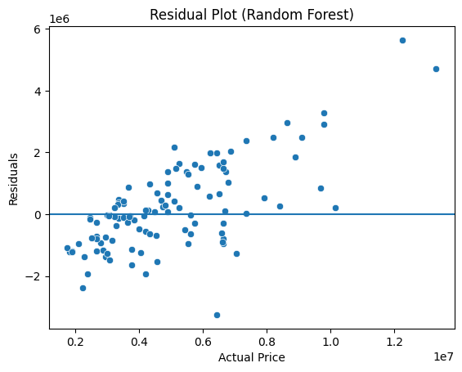
Insight: Errors are centered → model is stable.

7. Conclusion
- Area is the most influential factor in determining house price
- Ensemble models outperform simpler models
- Gradient Boosting provides the best performance
- Model is reliable but can be improved further with advanced feature engineering

